[**USB to Serial (Prolific 2303) Device Cannot Start (Code 10) in Windows 8**](http://leftbraintinkering.blogspot.com/2013/05/usb-to-serial-prolific-2303-device.html)

Is this a rare situation where a piece of legacy hardware works fine in Linux and is broken in Windows??  
  
The Prolific 2303 works perfectly fine in Linux Mint.  Yet, for some reason, [Prolific says](http://www.prolific.com.tw/US/ShowProduct.aspx?p_id=225&pcid=41) that some of these chips have reached the end of life and won't be 'supported' under Windows 8.  Prolific suggests that you purchase an updated chipset:

[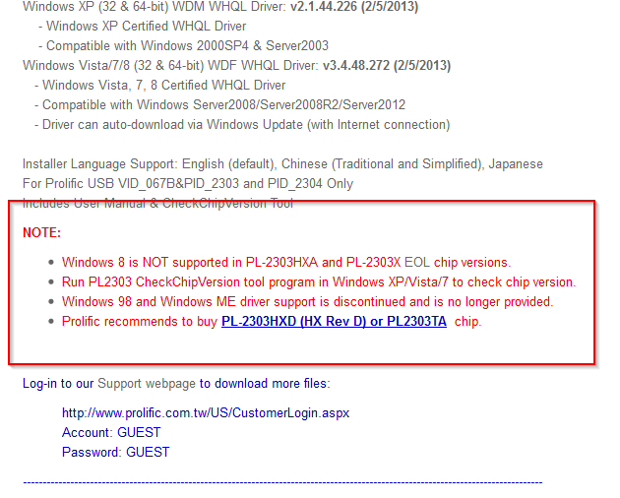](http://4.bp.blogspot.com/-Oo6Px3deeik/UYhaPjjxadI/AAAAAAAAIvs/bgULLHpSXlo/s1600/2013-05-06+21_33_44-Products.png)

So, a few questions -- what is different about the newer chips that they *can* be supported in Windows 8, while the older ones can't?  What has changed in Windows 8 that makes this support so different?  
  
Here's the yellow triangle with exclamation point that you'll see:

[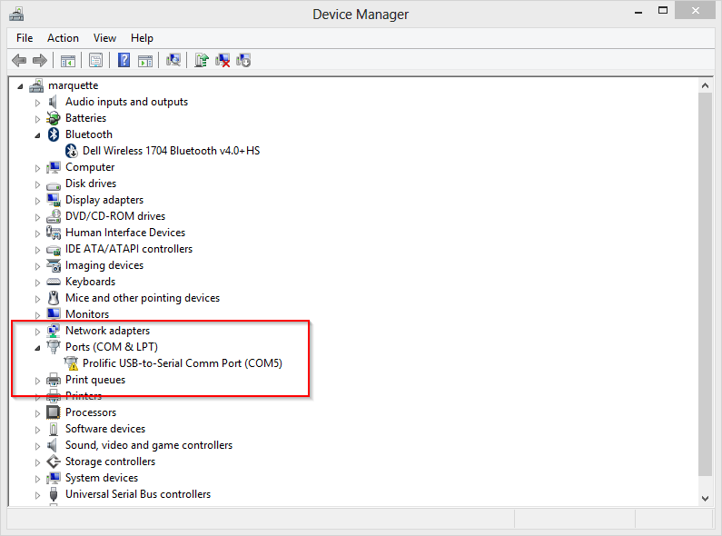](http://4.bp.blogspot.com/-CJydOmmytbE/UYhZMeKJQyI/AAAAAAAAIvg/BeiNkIC68d0/s1600/2013-05-06+21_26_43-Device+Manager.png)

And here is the "Code 10" error:

[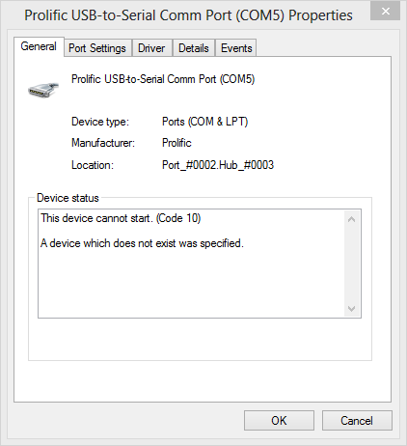](http://4.bp.blogspot.com/-oZSBOEq5s0E/UYhZJZdf3NI/AAAAAAAAIvc/o18usSEKz0w/s1600/2013-05-06+21_26_00-Prolific+USB-to-Serial+Comm+Port+%2528COM5%2529+Properties.png)

Fixing it:  Some [clever people](http://currentcost.com/support/viewtopic.php?f=19&t=33863) have figured out workarounds for this issue.  
  
Get this file: [Profilic_Win8_x64_x86.zip](http://www.sendspace.com/file/5m5afw)  
  
Extract the contents of this file somewhere and examine the contents:

[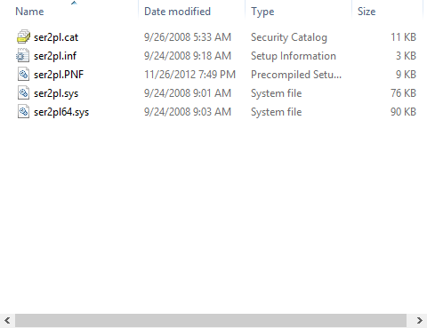](http://2.bp.blogspot.com/-YvxtKUEn9eA/UYhdE2adAAI/AAAAAAAAIwA/p5lLsow8zSc/s1600/2013-05-06+21_46_29-ShellView.png)

Right click the .inf file, and select "Install".

[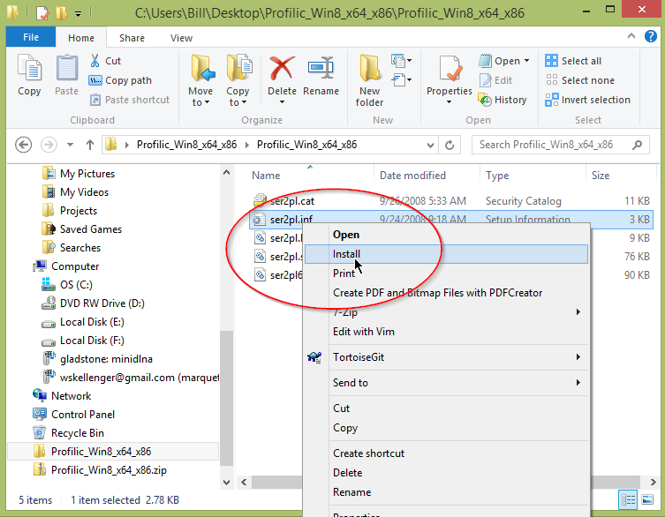](http://2.bp.blogspot.com/-BjIv89FpIV4/UYheG1icOSI/AAAAAAAAIwQ/MKHpIasdL4A/s1600/2013-05-06+21_47_45-Blogger_+Left+Brain+Tinkering+-+Edit+post.png)

I didn't notice that anything happened when I ran it.  Probably because I've tried so many different drivers and installations; maybe it was already installed, I don't know.  
  
Got back to the device manager and right click the Prolific USB to Serial comm port, and click "Update Driver Software".

[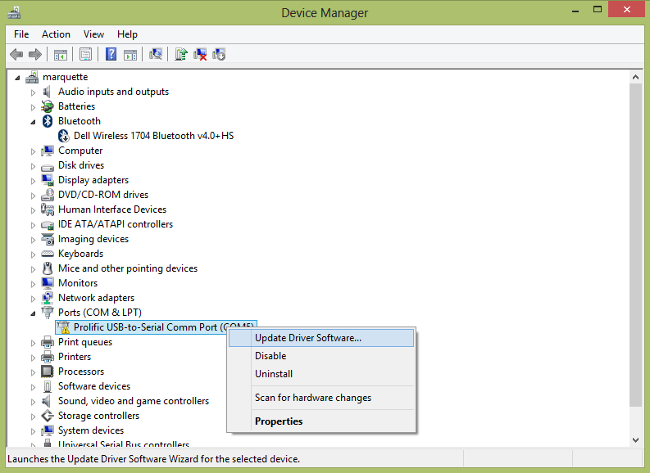](http://3.bp.blogspot.com/-V9qKLIORH5M/UYhglsNtYBI/AAAAAAAAIwc/mnGVJ-8h5z8/s1600/menu.png)

In the resulting dialog, click "Browse my computer for driver software":

[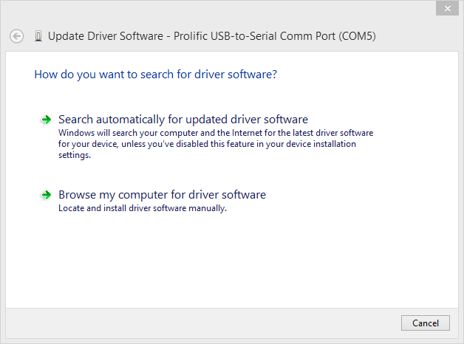](http://3.bp.blogspot.com/-bb8O-5s55Hk/UYhhjIWGn5I/AAAAAAAAIwk/v3qWOZBsBaE/s1600/2013-05-06+22_02_30-Update+Driver+Software+-+Prolific+USB-to-Serial+Comm+Port+%28COM5%29.png)

Select "Let me pick from a list of device drivers on my computer":

[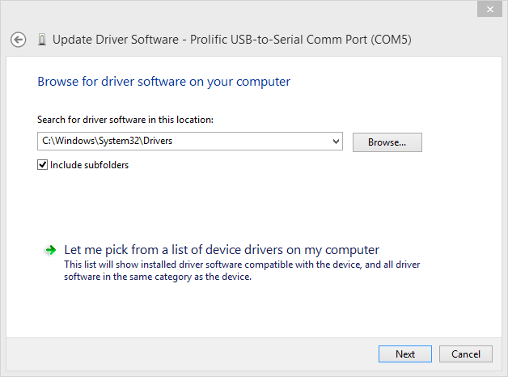](http://1.bp.blogspot.com/-qK4mjhOGnbE/UYhhjItldNI/AAAAAAAAIww/KvX7WJMhu4U/s1600/2013-05-06+22_02_52-Update+Driver+Software+-+Prolific+USB-to-Serial+Comm+Port+%28COM5%29.png)

Select the Prolific driver version 3.3.2 from 2008:

[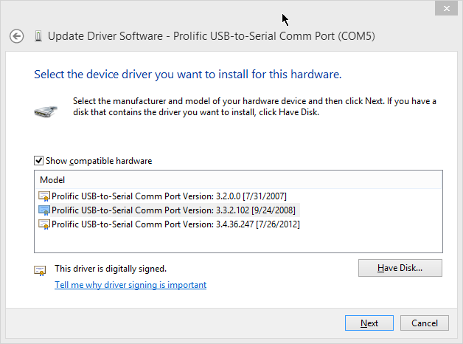](http://2.bp.blogspot.com/-HoaVigpfkhs/UYhhjEBfGRI/AAAAAAAAIwo/R0a7mXoKbos/s1600/2013-05-06+22_03_38-Update+Driver+Software+-+Prolific+USB-to-Serial+Comm+Port+%28COM5%29.png)

Win.

[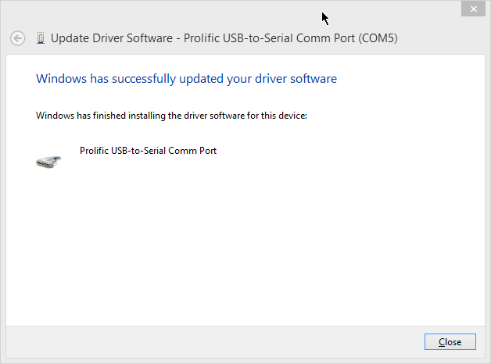](http://4.bp.blogspot.com/-zwv3uPSjFDQ/UYhhjcNTD7I/AAAAAAAAIws/onK_Gbb5zp0/s1600/2013-05-06+22_04_06-Update+Driver+Software+-+Prolific+USB-to-Serial+Comm+Port+%28COM5%29.png)

If all went well, you'll no longer see the yellow triangle:

[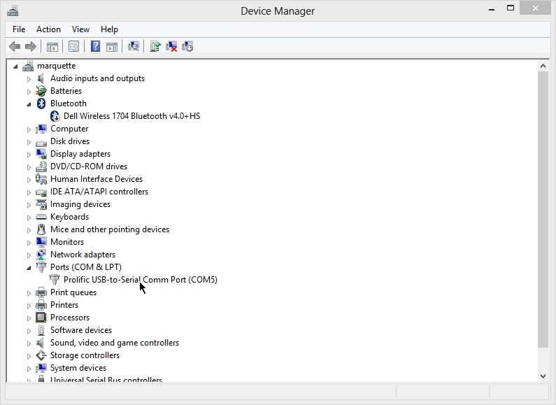](http://3.bp.blogspot.com/-DampkCCWpTI/UYhiMfpxp3I/AAAAAAAAIxI/kgOhaig_Peg/s1600/2013-05-06+22_07_39-Device+Manager.png)